Samsung Yesterdays Devices

Samsung steals march on Nokia with first Windows phone

"Microsoft or Windows never got their best results because of android doing very well. With the change in the legal environment, there's a case to be made that Samsung will likely shift some of those resources to broaden out or diversify their own exposure."
Nokia is going to unveil its new Lumia line of smartphones using Windows Phone 8.
Samsung’s ATIV S may promote expectations for Lumia. Samsung built the ATIV S with the latest and greatest technology, especially for anyone who want a super phone that’s equal parts powerhouse and head turner.

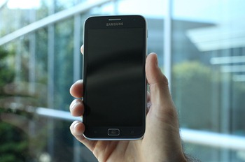
"The fact Samsung was allowed to be the first to announce is Microsoft's backhanded way of letting other vendors know that Nokia is not getting special treatment".
Microsoft promised the first Windows Phone 8 in market which is on the same core code as of Microsoft’s Windows 8 operating system but is actually a different product which will run on tablets and PC’s.
Samsung challenges that ATIV phone would hit stores in the October-November period this year.

